Nursery | Rosie’s Walk  Pat Hutchins  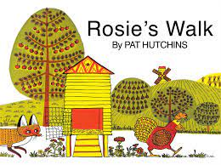 |  | The Gingerbread Man  Traditional Tale  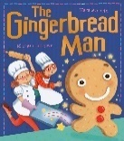 | Here We Go Round the Mulberry Bush  Iza Trapani  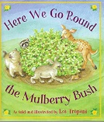 | The Three Little Pigs  Traditional Tale | Jasper’s Beanstalk  Nick Butterworth | The Very Hungry Caterpillar  Eric Carle
Reception | The Little Red Hen  Traditional tale  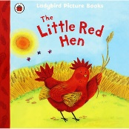 |  | Owl Babies  Martin Waddell  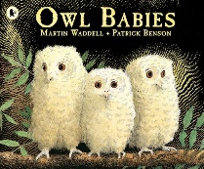 | Winter Sleep  Sean Taylor | The Three Little Wolves and the Big Bad Pig  Eugene Trivizas | Jack and the Beanstalk  Traditional tale | Once They Were Giants  Martin Waddell
Y1 | (Drawing Club- flow of codes)  Colour Monster  Chicken Licken  Don’t Forget the Bacon – Pat Hutchins  Gigantic Turnip  Hundred Decker Bus  Hairy Toe  (Curious Quests- flow of codes)  Meg’s Castle  Mixed  Princess Smartypants  Traction Man is Here  Christmas at the Toy Museum  Non-fiction:  Terrific Toys from the Past  Poetry:  Songs from the Singing Saucepan  Poetry Basket |  |  | (Curious Quests- flow of codes)  The Something  The Way Back Home  On Sudden Hill  The Story Machine  Izzy Gizmo  Mrs Armitage on Wheels  Non-fiction:  Levers  Poetry:  Songs from the Singing Saucepan  Poetry Basket  (Curious Quests-flow of codes)  My Cat likes to hide in Boxes  Oi Get off our Train  Angelica Sprocket’s Pocket  Little Rabbit Must Help  Non-fiction:  Sparky STEM Gudie to Trains  Poetry:  Songs from the Singing Saucepan  Poetry Basket |  | (Curious Quests- flow of codes)  Oi Frog  Where the Wild Things Are  Non-fiction:  Plants  Poetry:  Songs from the Singing Saucepan  Poetry Basket  (Curious Quests- narrative, letter)  Clean p  The Crocodile who didn’t like Water  Secret of Black Rock  Stanley’s Stick  Coming to England  Non-fiction (recount, report):  Seaside Holidays Then and Now  Poetry (shape poem):  Songs from the Singing Saucepan  Poetry Basket
Y2 | The Something  Rebecca Cobb  Contemporary fiction – adventure  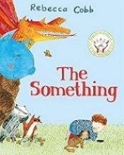  Narrative (to include character and setting  Description)  Non-chronological report  Don’t Look in this Book  Samuel Langley-Swain  adventure/ poetry  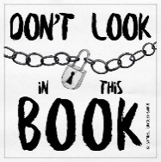  Poetry (list poems)  Recount/ diary |  | Vlad and the Great Fire of London  Kate Cunnigham  historical  Toby and the Great Fire of London  Kate Cunnigham  Historical  Diary entry  Setting description  Non-chronological report  Stick Man  Julia Donaldson  Classic contemporary fiction  Adventure  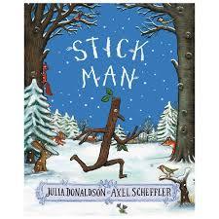  recount  Narrative (to include character and setting  Description)  Non-chronological report | The True Story of the Three Little Pigs  Jon Scieszka  Alternative fairy tales  Letter writing  Narrative (to include character and setting  Description)  Mr Wolf’s Pancakes  Jan Fearnley  Alternative fairy tales  Instructions  Poetry (acrostic poems)  Little Red Riding Hood and the Wolf – Revolting Rhymes  Poetry | Lila and the Secret of Rain  David Conway and Jude Daly  Stories from other cultures  Diary entry  Setting description  The Journey Home  Fran Preston Gannon  environmental  Diary  Letter writing  Non-chronological report | The Lighthouse Keepers Lunch  Ronda and David Armitage  Classic fiction  Instructions  Diary/ recount  Narrative (to include character and setting  Description)  The Storm Whale  Benji Davies  Contemporary fiction  Postcards  Fact files  Persuasive letter  Poems out Loud  Poetry  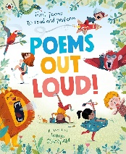  poetry |  | Billy and the Minpins  Roald Dahl  Classic fiction / adventure  Narrative (to include character and setting  Description)  Non-chronological report  Flat Stanley  Jeff Brown  humour/ adventure  Letter writing  Recount  Non-chronological report
Y3 | The Lion, the Witch and  the Wardrobe  C.S.Lewis  Fantasy  Narrative story / descriptions  Poetry  Diary entry  Instructions  Biography of Author |  |  | Stone Age Boy  Satoshi Kitamura  Historical / Humour  Descriptions and Conversational writing  Recount (linked to a workshop) | Midnight’s Summer Dream  Comedy / Fiction  Poetry – Kennings and Quatrains  Explanation  Newspaper report | Here Comes Hercules  Stella Tarakson and Nick Roberts  Historical  Narrative story  Letter  Non chronological report  Poetry – Question and Answer poems  Diary entry
Y4 | Leon and the Place Between  Graeme Baker Smith  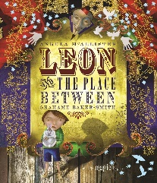  Fantasy / Adventure  Narrative (to include setting description / character description) / Instructions  / The Grinch who Stole Christmas  Dr Seuss  Rhymed verse / Christmas  Diary Entry  Explanation (linked to science) |  |  | Voices in the Park  Michael Morpurgo  Contemporary realistic fiction / Picture book  Letter  Discussion | Stig of the Dump  Clive King  Fantasy / Adventure  Non chronological report  Newspaper report | Counting on Katherine  Helaine Becker  Non-fiction  Biography  Play script  Poetry focus – cinquain
Y5 | The Iron Man  Ted Hughes  Science Fiction/ classic fiction  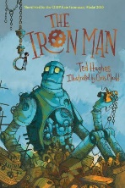  Narrative (to inc. character setting, description, conversational writing)  playscript  Biography (linked to art) | Wk 1 -3  Poetry focus  Limericks  Black out poetry (linked to Remembrance Day)  Wk 4 – 6  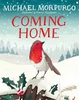  Coming Home  Michael Morpurgo  Adventure  Diary/ journal entries  Newspaper report |  | The Nowhere Emporium  Ross MacKenzie  fantasy  Narrative (to inc. character and setting description, conversational writing, journal)  Discussion/ balanced argument  Recount/ diary  Letter  Persuasion  News report (possible)  Instructions (linked to Easter) |  | The Explorer  Katherine Rundell  adventure  Non-chronological report  Narrative  Diary entry  News report  Explanation
Y6 | Cogheart  Peter Bunzl  Adventure / Steampunk / historical  5 plagues of Reading  Narrative writing in role – Fair's Fair  Setting description  Character description  Diary entry  Letter  Suspense story writing  Explanation – How we see  Dialogue  Balanced Argument - Railways  War Poetry |  |  | Holes  Louis Sachar  Mystery / Social Issues  Contemporary Fiction  Persuasive writing – speeches, brochures, adverts  Poetry writing  Book review  Character description  Setting description  Comic strip  Recount  Non-chronological report - lizard |  | Floodlands  Marcus Sedgwick  Adventure/ Enviromental Issues  Dystopian Fiction  Narrative writing in role  Newspaper report writing  Letter writing  Setting description  Character description  Diary entry  Letter writing  Biographical writing  Persuasive advert

